# ✈️ Travel Booking App UI

## 📖 Project Overview

The **Travel Booking App UI** is a mobile application interface designed using **Figma**. The application provides users with a simple and attractive interface to search for travel destinations, book flights, and manage their travel plans.

This project was created as part of the **UI/UX Design Laboratory** to demonstrate the principles of user interface design and user experience.

---

## 🎯 Objective

To design a modern, user-friendly, and visually appealing mobile application for booking travel tickets and exploring travel destinations.

---

## ✨ Features

- Attractive Splash Screen
- User Login Interface
- Home Screen
- Search Destinations
- Destination Details
- Flight Booking
- Payment Screen
- Booking Confirmation
- User Profile

---

## 🛠️ Tools Used

- Figma
- GitHub

---

## 📱 Screens Included

- Splash Screen
- Login Screen
- Home Screen
- Search Screen
- Destination Details
- Booking Screen
- Payment Screen
- Profile Screen

---

## 🖼️ Screenshots





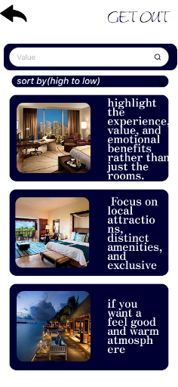
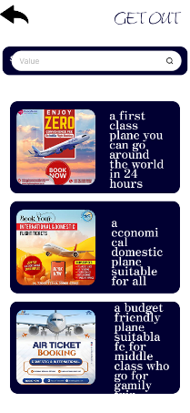
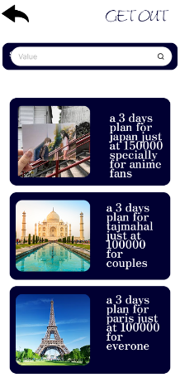




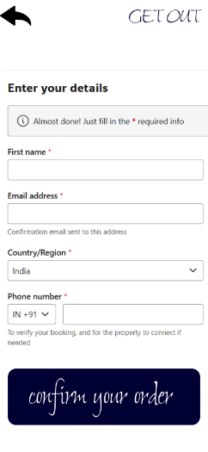

## 🎨 Design Highlights

- Simple and clean user interface
- Consistent color palette
- Easy navigation
- Modern typography
- Mobile-friendly layout
- User-centered design

---
## 🔗 Figma Prototype
https://www.figma.com/proto/hcEUSyCeckychwlyhMvm63/Untitled?node-id=0-1&t=6rP5015JI5HRxUIs-1
## 📂 Project Structure

```
Travel-Booking-App-UI/
│
├── README.md
├── Screenshots/
│ ├── Splash.png
│ ├── Login.png
│ ├── Home.png
│ ├── Search.png
│ ├── Booking.png
│ ├── Payment.png
│ └── Profile.png
│
└── Assets/ (Optional)
```

---

## 👨‍💻 Developed By

**Student Name:** - A . John samuel
**Register Number:** - 2617008
**Department:** - BCA-A
**College:** -kamaraj college ,thoothukudi
---

## 📜 License

This project is created for educational purposes only.

